Acknowledgment of Biosafety Manual Review

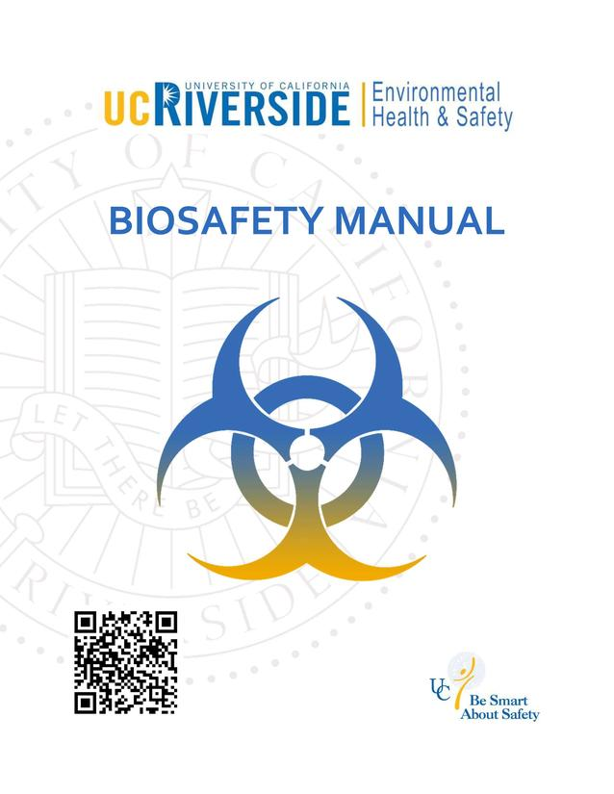
https://ehs.ucr.edu/laboratory/biosafety-manual

Instructions: Please visit the link above, review the contents of the biosafety manual, and sign off the acknowledgement below on an annual basis. Keep a copy of this signed acknowledgement in your lab safety manual.

I hereby acknowledge that I have reviewed the biosafety manual.
I agree to abide by the principles and procedures that were explained in this manual. I understand that if I have any questions about the materials presented or information not addressed in the manual, or if I encounter any problems, it is my responsibility to seek clarification from the Biosafety Officer(s) at Environmental Health & Safety (EH&S).

Acknowledged:

Date Biosafety Manual Reviewed | Print Name | Signature

