**Checklist for Safe Use of Class II Biological Safety Cabinets (BSCs)**

This checklist is a basic template that you can use as a reminder on how to work safely in a BSC to maximize personnel, product, and environmental protection against biohazardous materials.

## Preparing for work in a BSC:

Turn off UV light if on.

Check the certification sticker and ensure it has been **certified within the last year** (Figure 1). Contact Technical Safety Services (TSS) if recertification is needed.

Ensure **sash is at operating height** (Figure 2) and turn on BSC motor and fluorescent light. Allow the BSC to run for 10 minutes (or manufacturer’s recommended time) to purge the cabinet of particulates.

Check for any alarms. Check that the drain valve underneath the cabinet is in the **closed** position (valve handle is perpendicular to valve body) (Figure 3).

While wearing appropriate personal protective equipment (PPE), decontaminate cabinet with disinfectant and load materials you’ll be working with into the cabinet. Do NOT overload the cabinet or keep unnecessary materials within the cabinet to minimize cross contamination of unused materials. *Note: Surface decontaminating materials prior to bringing them into the cabinet will minimize the introduction of outside contaminants into the sterile environment of the BSC.*

## Working in a BSC:

Do NOT block front, rear, (and side on some models) airflow vents/grills with materials.

Work with materials at least 4 inches inside the BSC.

Work in one direction across the BSC to minimize cross contamination (Figure 4).

Use slow/deliberate movements within the BSC to minimize airflow disruption. Exit the BSC perpendicular to the cabinet face. Do not swing hands and arms out of the cabinet.

Discard all waste in a compliant biohazard waste bag **inside** the BSC.

Do not use open flames within the BSC (see [EH&S guidance for open flames in a BSC](https://ehs.ucr.edu/document/open-flames-bsc)).

## After working in a BSC:

Close and surface decontaminate all containers, supplies, and equipment before removing them from the cabinet. Place materials back in their storage areas. Avoid using the cabinet as a storage area.

Close and transfer biohazardous waste bag to collection bin or EH&S provided bins for pickup.

Decontaminate interior surfaces of BSC (work surface, side and back walls, and inside of sash) with appropriate disinfectant.

Turn cabinet motor and fluorescent light off.

Remove gloves and wash your hands with soap and water.

## Internal view of the biosafety cabinet with arrows pointing to the vents/grills in the perimeter of the cabinet. Diagrams and Pictures:

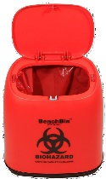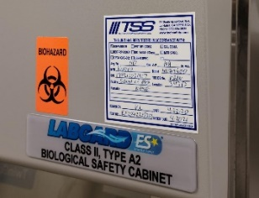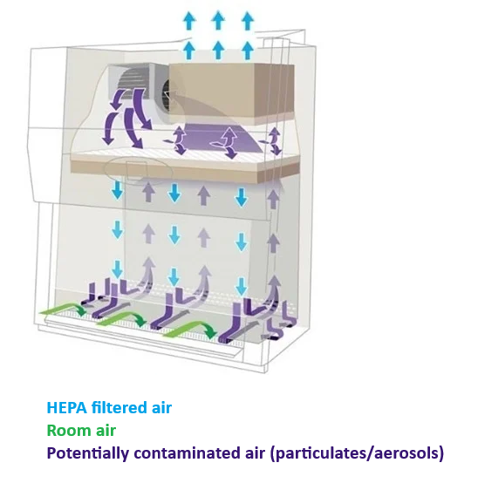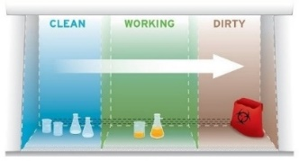Close-up of a drain valve position diagram.

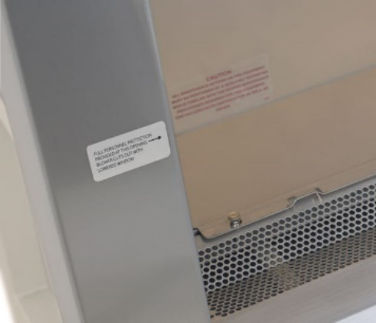

HEPA filters

Laminar flow

Airflow vents/grills (Do not block)

Airflow diagram of a Class II A2 BSC

Figure 2 – Operating sash height

Figure 1 – TSS certification sticker

Figure 4 – Working in one direction across a BSC (clean to dirty)

Figure 3 – Drain valve positions